

Application Name: Every Catalog

Prepared By: Syed Tabish Ishtiaq

Objective of Document: To Cover Testing Types those can be conducted on this Web Application

1. **W3C Validation:**

(**W3C**) that allows Internet users to check HTML and XHTML documents for well-formed markup. Markup **validation** is an important step towards ensuring the technical quality of web pages

**Objective:**

To Validate html and CSS markup languages standard coding of web

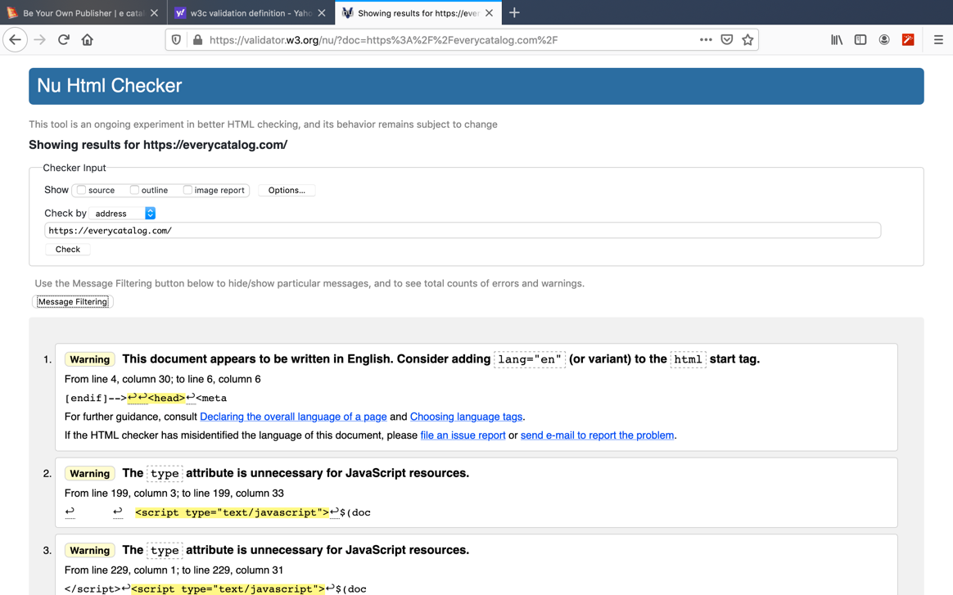

1. **Cross Browser Testing:**

Determine Application Behavior on Different Browsers

* 1. Chrome:

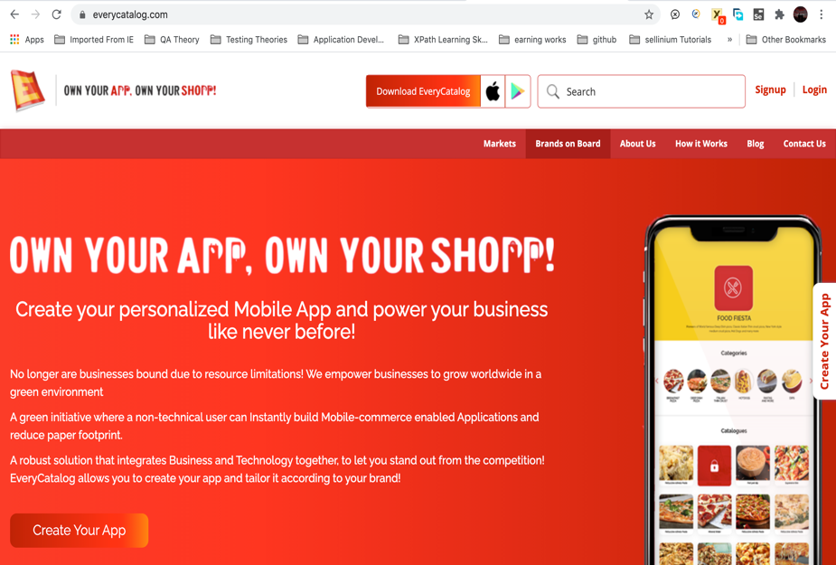

* 1. Fire Fox:

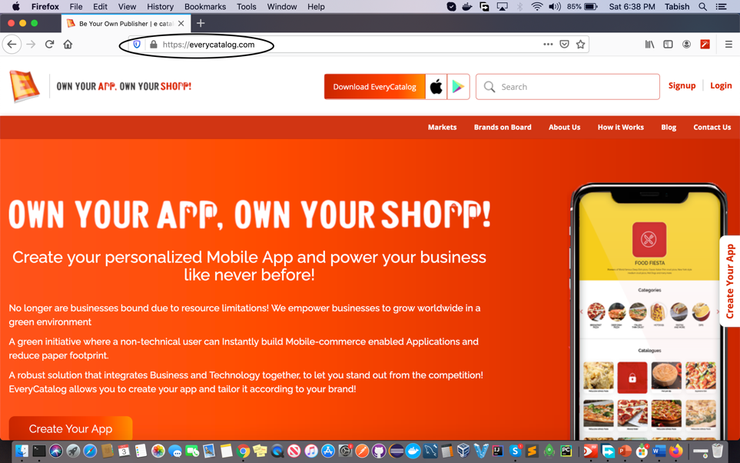

1. **Black-Box Testing:**

Is Based on Requirement and functionality. Is Application Functions being behaves according to requirement or not

i.e. clicking button, downloads, dropdown, signup form, login form, searching, sorting, curd operations etc.

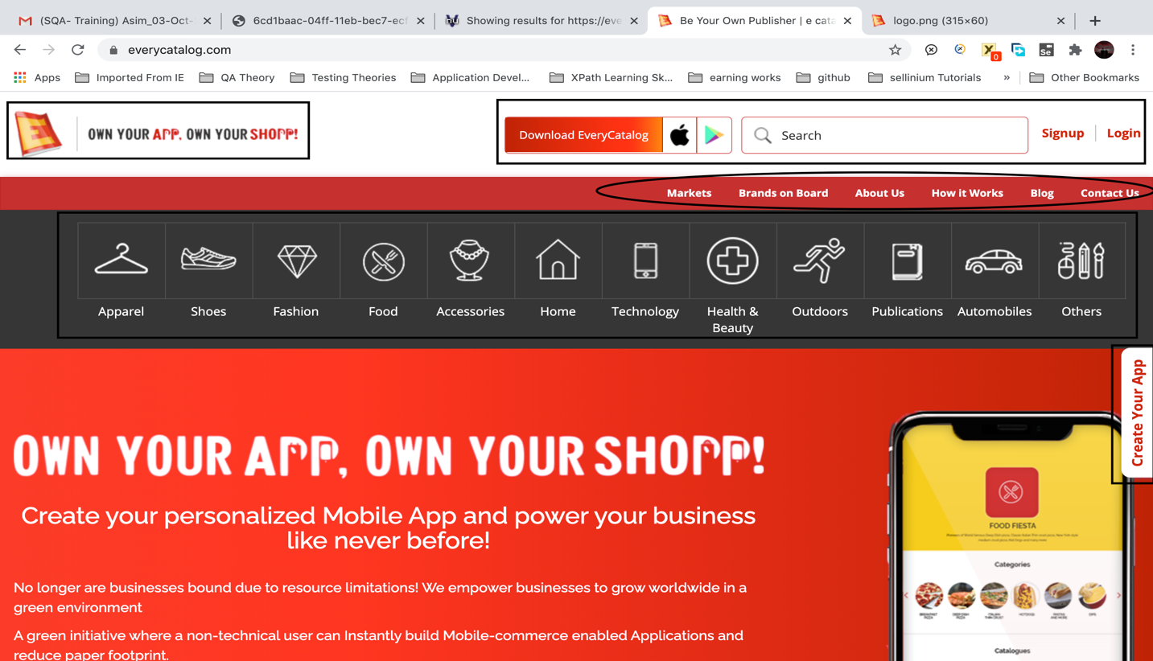

1. **White/Glass-Box Testing:**

**4.1** Scenario 1: Path Coverage

Functionality: Download Every Catalog

Target Path Sources:

Apple Play Store:

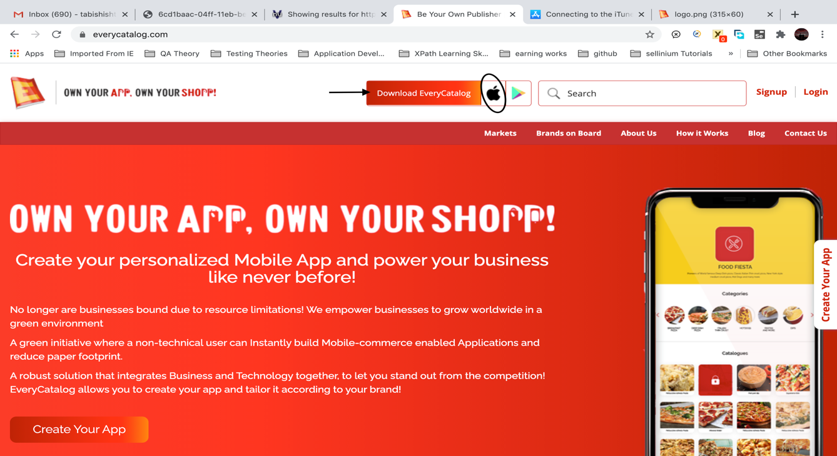

Google Play Store:

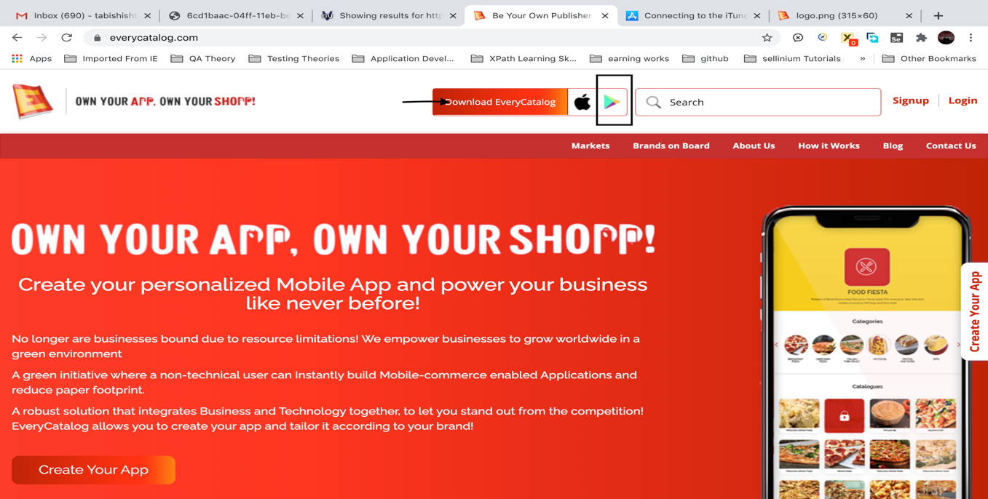

**4.2** Scenario 2: Decision (Conditions, Statements)/ Code Coverage

Functionality: Search Bar (To fetch out result according to search criteria)

Target Source for Search: Fashion

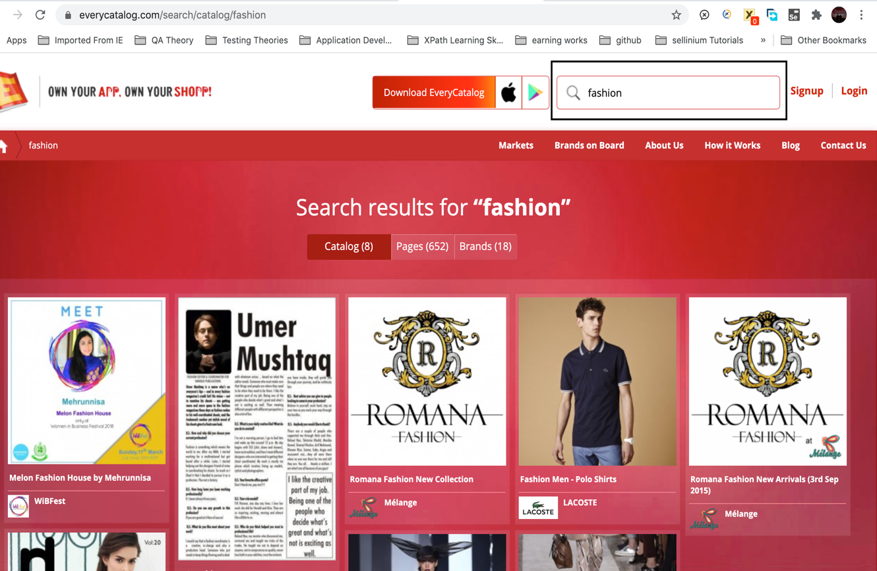

1. **Functional Testing:**

Tests the output of available functions in app that those are behaving as expected or not.

* 1. **Available Functions on App Home Page**:

Downloading, Search, Signup, login, Dropdown, Markets, Brands on Board, about us, how it works, Blog, contact us, create your app, sharing of app link on social media

* 1. Scenario 1: Button

Functionality used: Click

Target Source: Signup (Home Page Redirects to Signup form page after clicking sign up Button)

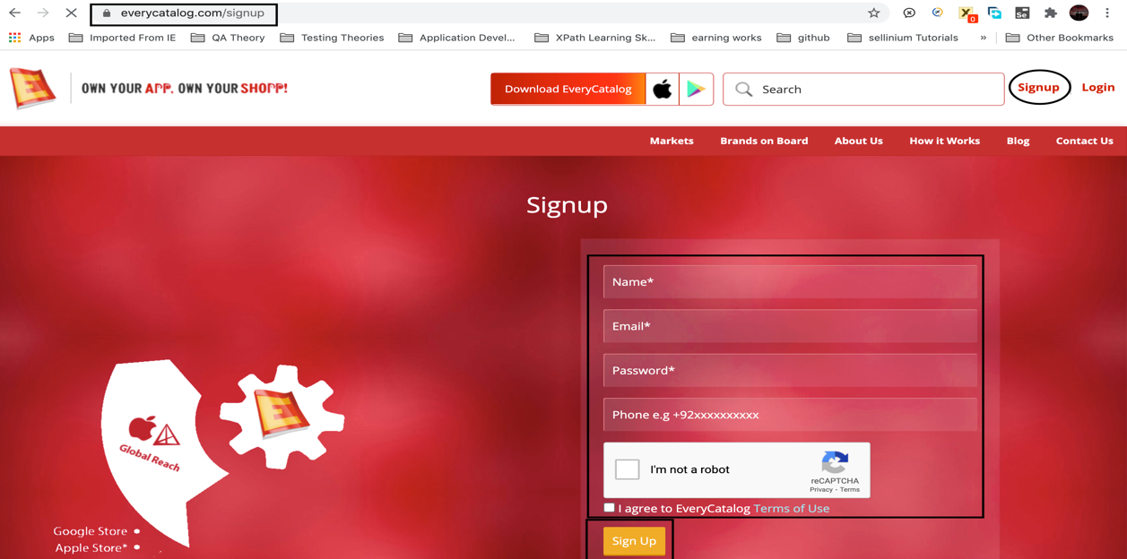

1. **Integration Testing:**

Is to expose bugs in the interaction between integrated units or modules.

**6.1** Scenario: we have application with signup functionality

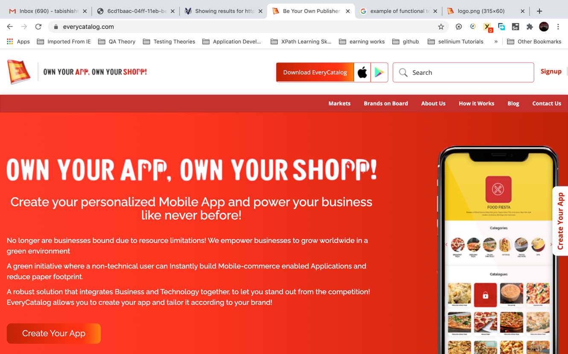

Integrate login Functionality in app, we test signup and login functionality both.

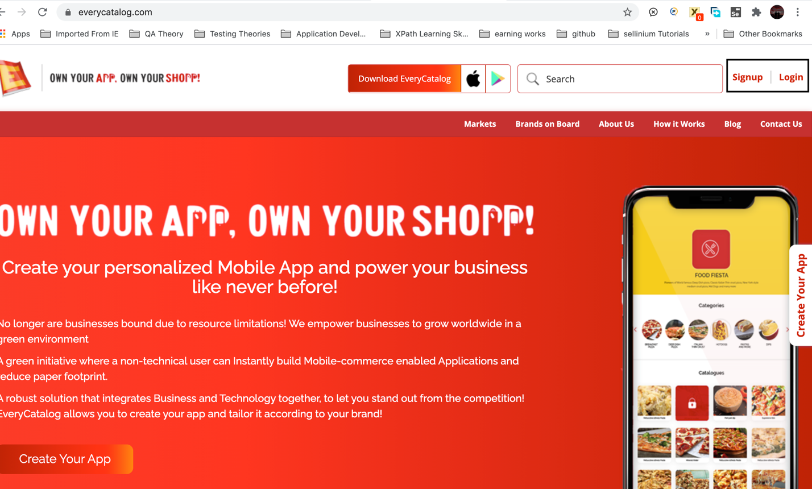

1. **System Testing:**

Perform on whole selected single domain version of app whether it can be web application, desktop application or android application version of app.

Domain selected: Web application

Perform complete testing of available functions of modules and sub modules of an application build for functions

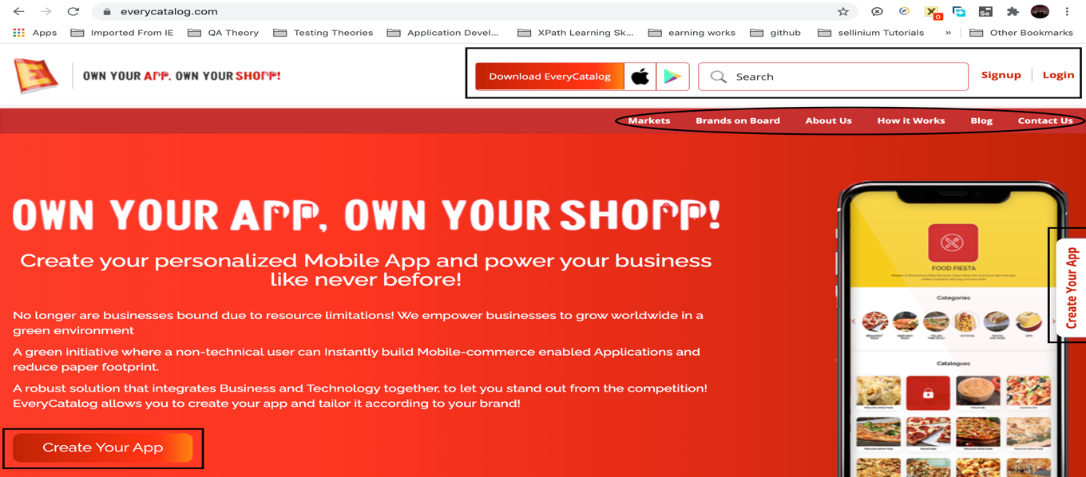

1. **Sanity Testing:**

Perform to determine the stability of the build or system if the any major bugs identify or build crashes initially tester will stop further testing until developer fixes the issue because build is not stable for testing.

* 1. Scenario: Selection of product for view selected brands having that product

Target Functionality: click on markets, click on shoes result shows all brands and stores having shoes as a product

**Bug:** Shoes is not listed in the departmental product list

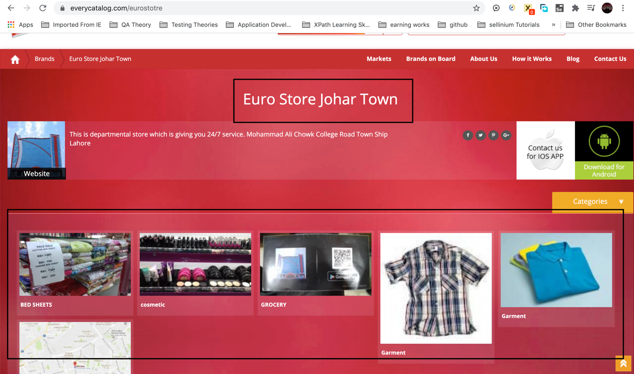

1. **Regression Testing:**

It is performed when any new module is integrated in a responsive application to identify the bug in resulting of adding new module to an application.

* 1. Scenario: Having activated application with markets, brands on board, about us, how it works, blog modules.

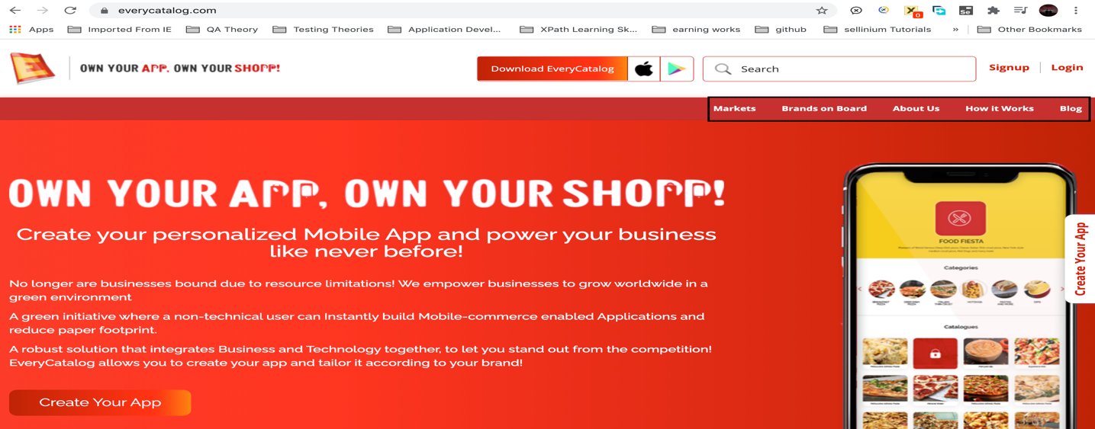

Now integrated contact us module to application, so now we perform regression testing on application after integration to catch bugs in application if any in resultant of integration of contact us module

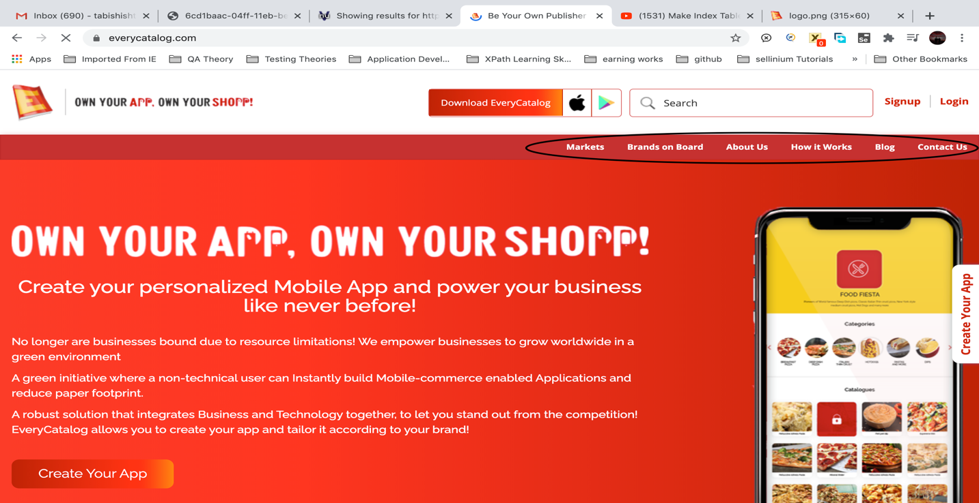

1. **Load Testing:**

It performed to determine the performance of an application. How it performs in various scenarios such as continuously hitting a sign in button

* 1. Scenario: Video load testing

Buffering time

Loading time

Rendering time

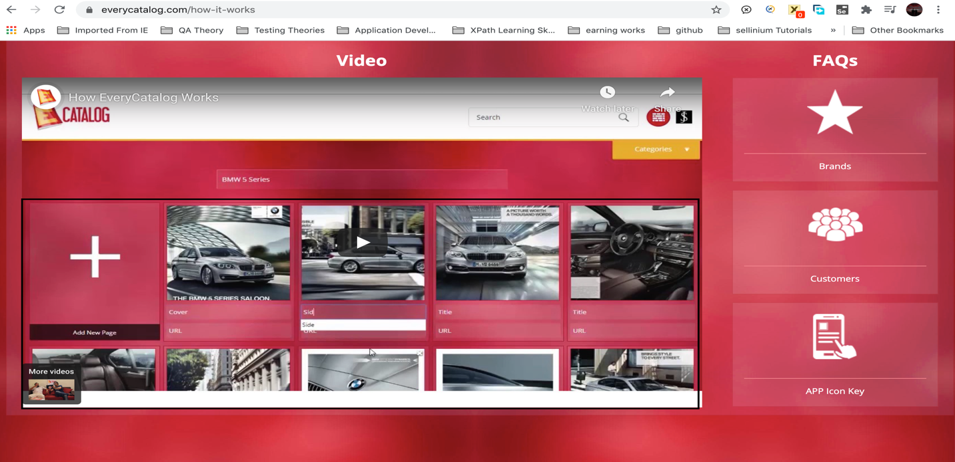

1. **Stress Testing:**

It performed by overloading the application to determine its break’s point.

* 1. Scenario: Log in (Character input limit, @sign for email etc.)

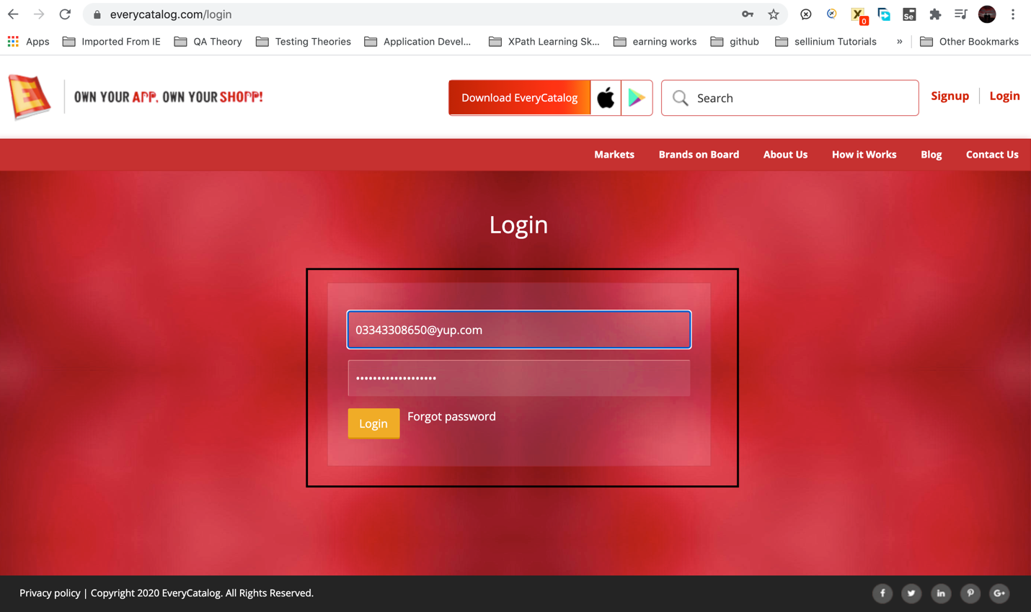

1. **Performance Testing:**

It performed to determine is system meets the performance requirements such as Main Functions, Stress, Time and Load.

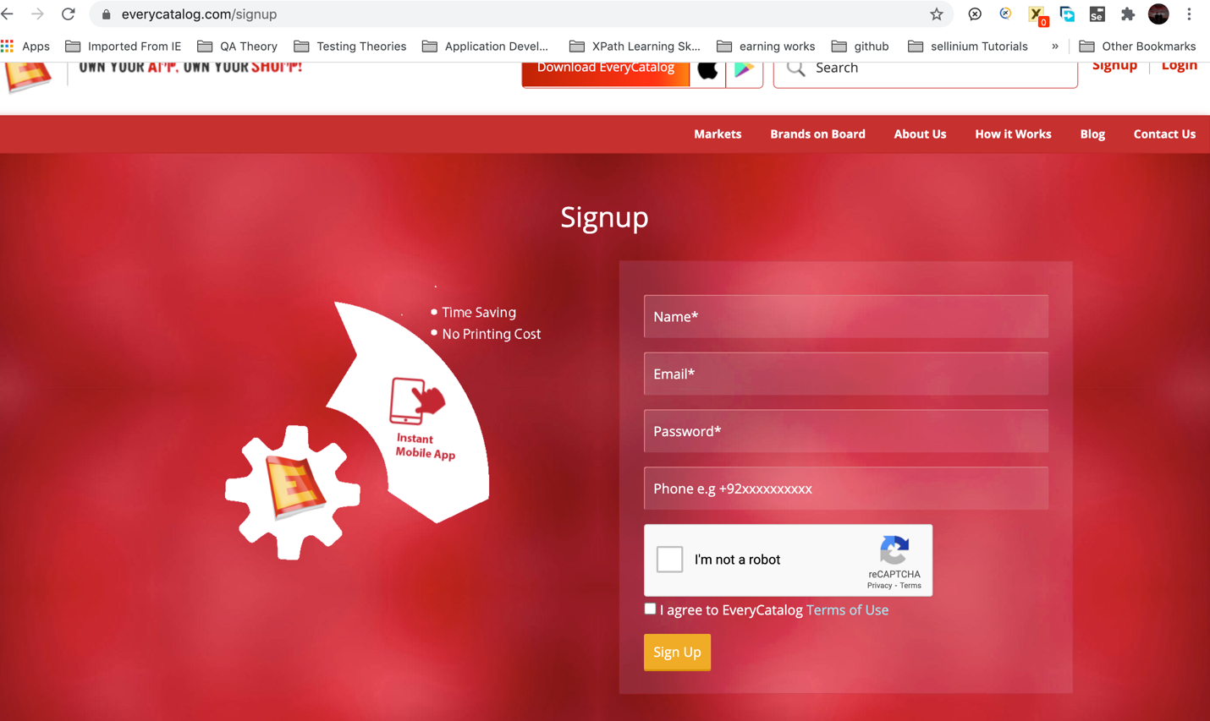

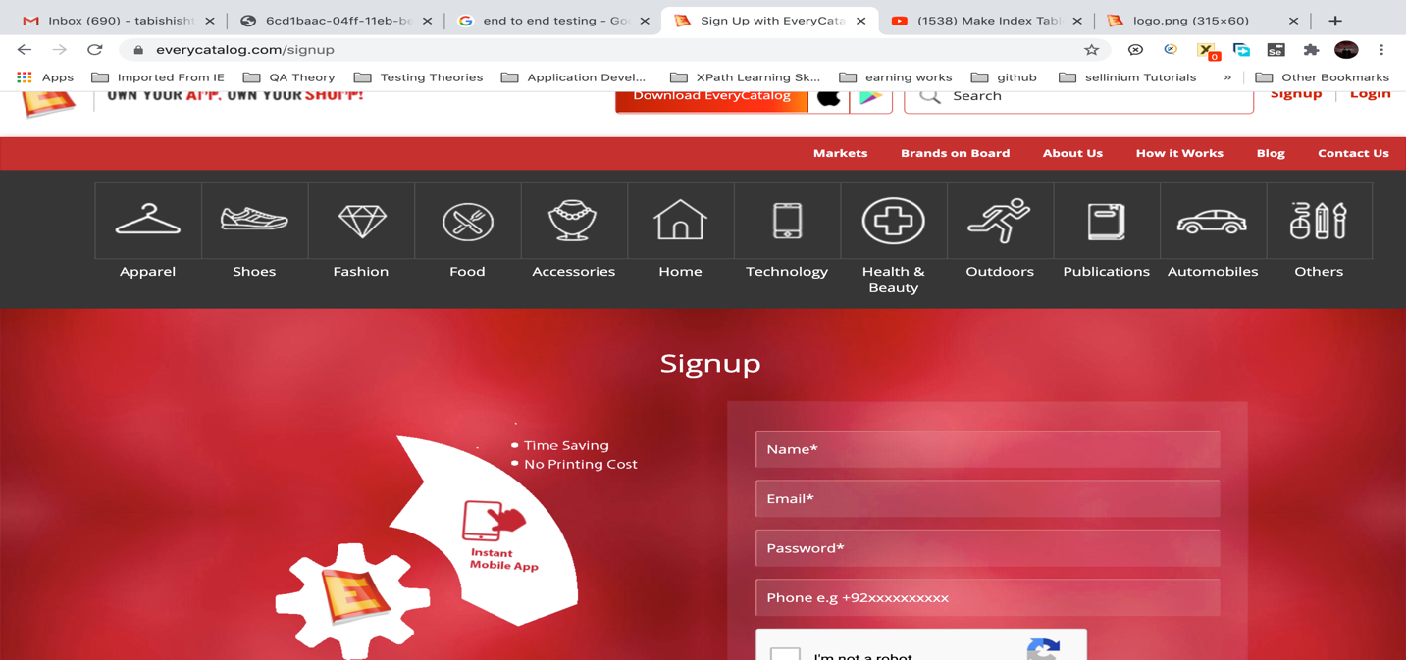

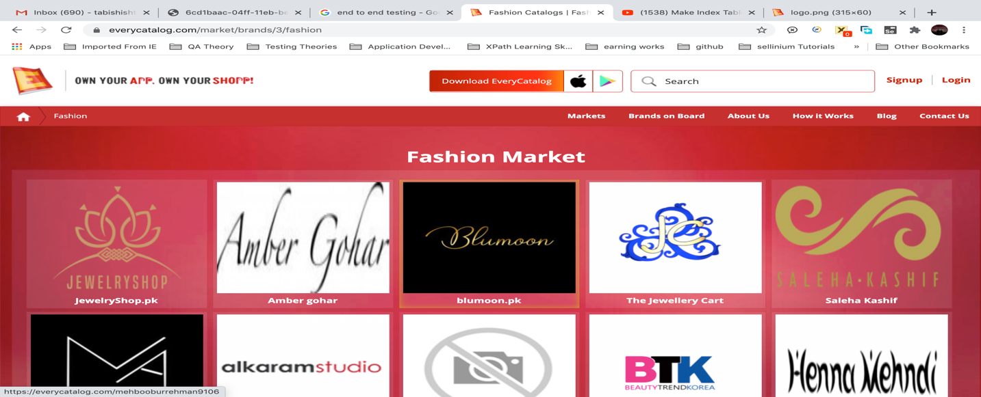

1. **Usability Testing**

How much application is user friendly, An Application flow is tested, can new user understand the application easily, proper help documented whenever user stuck at any point.

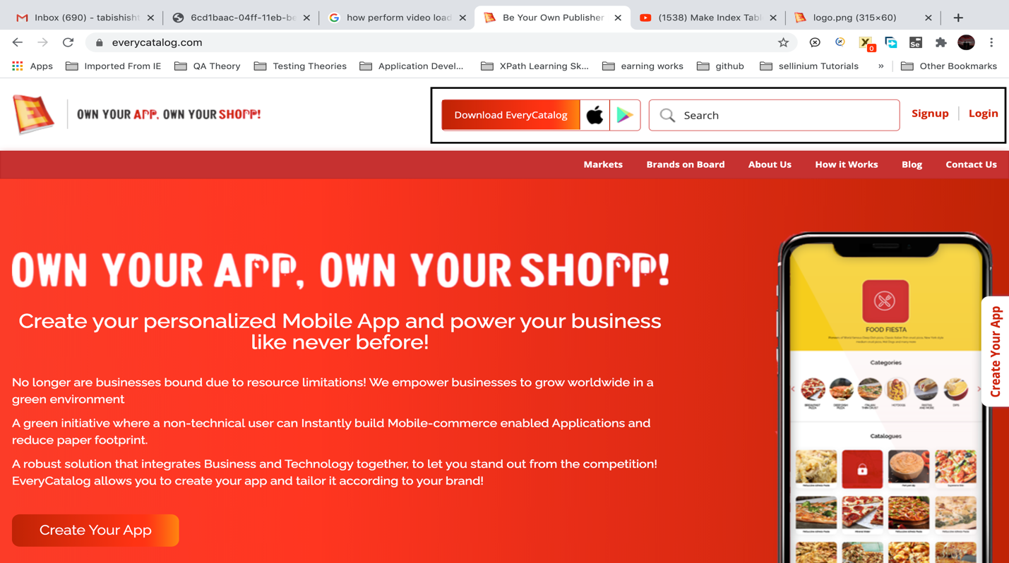

1. **End-to-End Testing:**

Done in systematic way based on application flow from start to end.

14.1 Scenario: Sign-up, log-in, so on

**15. Monkey Testing:**

Jump from one module to another from one function to another of an application.

